|  |  |
| --- | --- |
|  | |
|  |  |
|  | |

|  |  |
| --- | --- |
| 41 North Rio Grande Street, Suite 106 Salt Lake City, UT 84101 801.736.4100 **www.rsginc.com** |  |
| **prepared for:** |
| Utah Department of Transportation |
| **Submitted By:** |
| rsg |
|  |
|  |
|  |

1.0 Managed Motorways 3

1.1 | Methodology 3

Managed Motorway Functional Types 3

Changes to the Highway Network Coding 6

General Parameters 7

Volume-Delay Function (VDF) 8

Managed Motorways Static Input Files 9

Network Processor Script Edits 11

Distribution and Final Assignment Script Edits 12

1.2 | Results 15

Assignment Convergence 15

Ramp Penalties 17

Effects on Vehicle Miles Traveled and Transit 17

**List of Figures**

Figure 1: Managed Motorways Functional Types and Capacity 4

Figure 2: 2050 Managed Motorways Facilities in WFCCS 5

Figure 3: Separating Freeway Links at External Nodes 6

Figure 4: Separating Freeway Links on Two-way Links 7

Figure 5: General Parameters Added Variables 8

Figure 6: Volume-Delay Function Parameters 8

Figure 7: Volume-Delay Function Chart 9

Figure 8: Initial Ramp Penalty and Adjustment Factor Lookup 10

Figure 9: Maximum Ramp Penalty Lookup 10

Figure 10: Excerpt of Ramp-Freeway Lane Lookup File 12

Figure 11: AM Assignment Convergence Results 16

Figure 12: PM ASSIGNMENT CONVERGENCE RESULTS 16

Figure 13: MD ASSIGNMENT CONVERGENCE RESULTS 16

Figure 14: 2050 Base Scenario Final Assignment Ramp Penalties 17

Figure 15: 2050 Base Scenario VMT with and without Managed Motorways 18

Figure 16: 2050 Base Scenario Transit Ridership with and without Managed Motorways 18

# Managed Motorways

The Utah Department of Transportation (UDOT) is interested in better strategies to manage freeway traffic operations and has commissioned work to study and subsequently plan for a new method of managing freeway traffic operations. This work is known as Managed Motorways. The Utah rollout of the Managed Motorways concept would use ramp metering, real-time communication, and advanced computer algorithms to monitor and control freeway demand at the access points (including freeway on-ramps from arterials as well as system-to-system interchanges) to maintain freeway volumes just before breakdown; this would shift delay from the freeway mainline to the ramps.

Under this system, ramps—including system-to-system ramps—could experience significant delay, up to four minutes or more in the initial rollout, depending on the magnitude of freeway demand. Managed Motorways would require coordination between ramps and the ability to share ramp delay with up to 10 ramps upstream, creating gaps to accommodate downstream demand and alleviate excessive individual access point delay.

The travel model’s previous configuration uses standard link-based capacity and volume-delay functions to slow the facility as congestion increases. However, this method does not account for the Managed Motorways operational strategies. As part of WFCCS, the travel model was modified to reflect the Managed Motorways strategies. Model changes included the following:

* Created new functional types related specifically to Managed Motorways facilities.
* Revised the input highway network coding methodology.
* Added parameters to “0GeneralParameters.block” file.
* Updated the volume-delay function parameters lookup file.
* Added input files in the “_Inputs\6_Static\5_Assignment” folder to set the Managed Motorways parameters.
* Edited the “0_InputProcessing\c_NetworkProcessing\1_NetProcessor.s” script.
* Reworked the Distribution and Final Assignment scripts and block files.

## Methodology

### Managed Motorway Functional Types

Managed Motorways is “activated” in the travel model by setting the link’s functional type to a Managed Motorways functional type. All links, including ramp and system-system links, that are intended to be part of the Managed Motorway system are coded with the Managed Motorway functional types. Figure 1 shows the new functional types that were added to the travel model to account for Managed Motorways.

Figure 1: Managed Motorways Functional Types and Capacity



The Managed Motorways functional types mirror the freeway functional types’ numbering scheme. The value of the Managed Motorways freeway-freeway loop ramps, C-D roads/flyover ramps, and freeway functional types are 10 less than general-purpose functional types; Managed Motorway on and off ramp functional types are 13 less than general-purpose functional types. The structured nature of the Managed Motorways functional types allows for easier coding of the highway network.

Capacity values for Managed Motorway freeway lanes are set higher than general-purpose lane capacity values. According the Managed Motorway study, higher Managed Motorway capacities reflect that freeways are managed to just before breakdown (i.e., theoretical capacity) rather than the capacity the freeway operates during breakdown conditions (operational capacity, which is assumed for general-purpose lanes). Free flow speeds for Managed Motorways facility types are the same as their companion functional types.

The travel model looks up speeds and capacities via the following file: “_Inputs\6_Static\0_SpeedCap \Lookup_Speed_Capacity.csv.” In previous model versions, this input file was a .dbf file type rather than a .csv file type. As part of the Managed Motorways change this file was converted to a .csv file type and the model scripts referencing this script were updated accordingly.

Figure 2 depicts the facilities designated as Managed Motorways, which was assumed as a base condition for all WFCCS 2050 scenarios. All urban interstates in the travel model were designated as Managed Motorway facilities. Red lines represent Managed Motorway facilities; blue lines represent general-purpose freeway lanes.

Figure 2: 2050 Managed Motorways Facilities in WFCCS

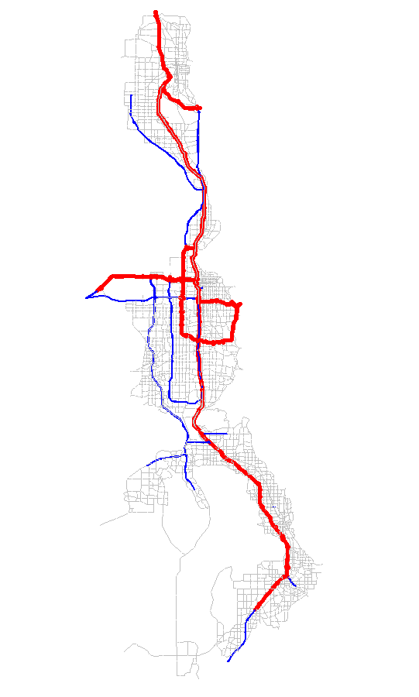

### Changes to the Highway Network Coding

Freeway links must be continuous in one direction—but cannot form a loop—in order for Managed Motorways to run in the model. Loops are formed when reverse direction links are connected to the forward direction of the link. In the previous version of the model, loops in the freeway network links were occurring at the external node connection and on certain arterials that convert in future scenarios to freeways (e.g., Bangerter Highway). These loops were eliminated in the current model by separating the freeway directions into independent link sets, as shown in Figure 3 and Figure 4.

Figure 3: Separating Freeway Links at External Nodes

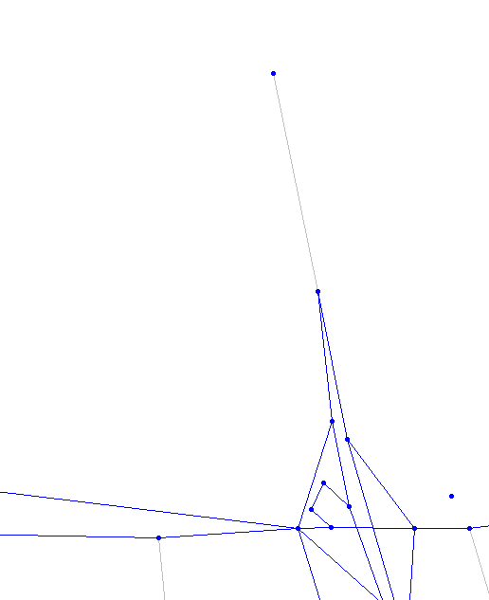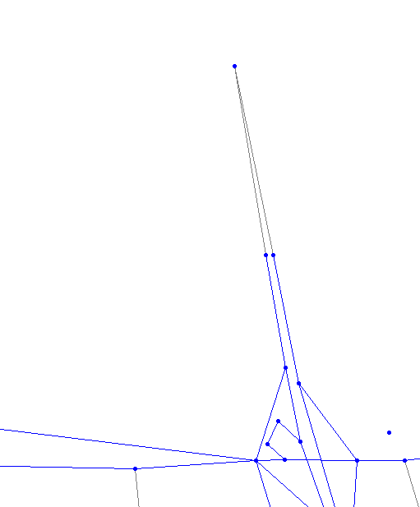

Figure 4: Separating Freeway Links on Two-way Links

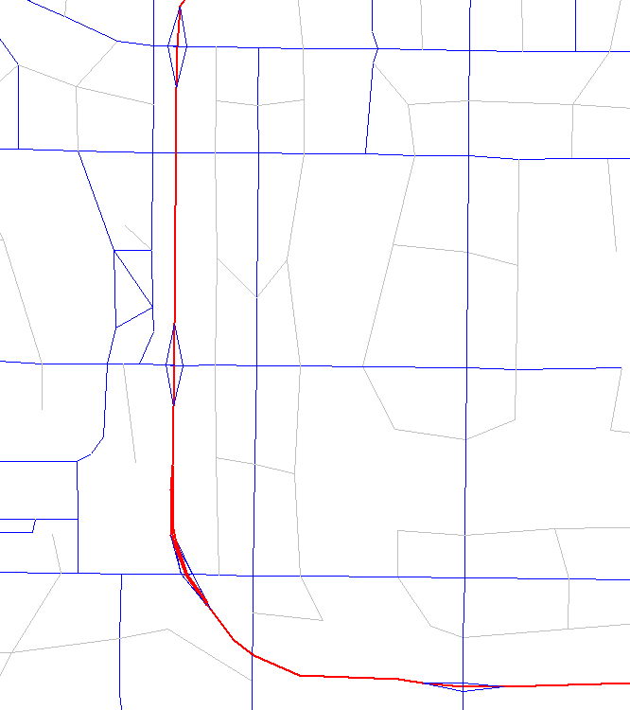 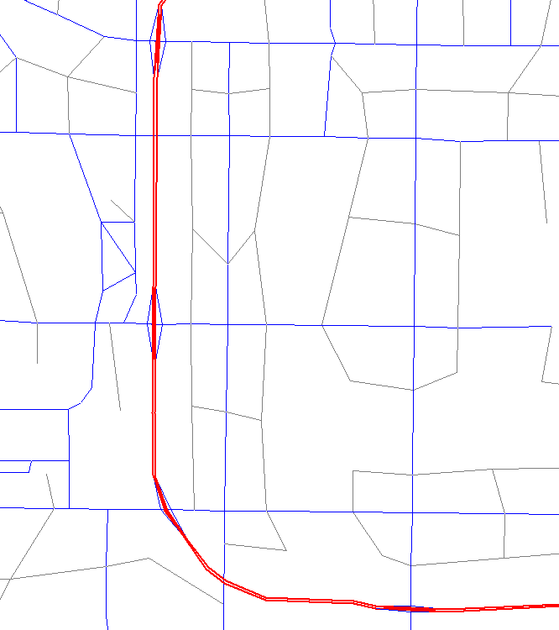

### General Parameters

Figure 5 lists the variables added to the “0GeneralParameters.block” file as part of the model update (red boxes indicate new variables). These variables tell the model which functional types trigger the Managed Motorways calculations used in the network processing step and set parameters for adjusting ramp penalties.

Figure 5: General Parameters Added Variables

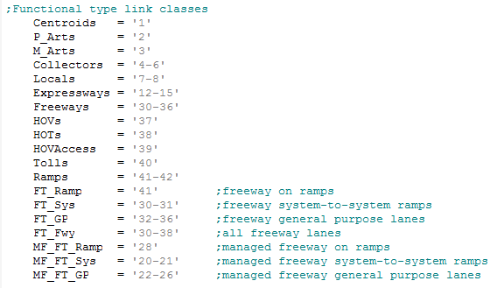

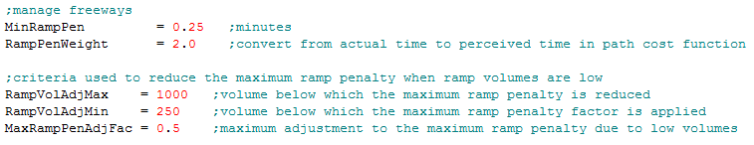

### Volume-Delay Function (VDF)

Managed Motorway freeway links use the same volume-delay function (VDF) parameters as the general-purpose freeway links, except the Managed Motorways maximum V/C ratio is capped at 0.97 to reflect the operational goals, whereas general purpose lanes are allowed to exceed a V/C ratio of 1. The VDF Managed Motorways parameters for ramps use the same parameters as the non-Managed Motorways ramps. Figure 6 shows the VDF parameters, by link class, used in the updated model (the travel model’s VDF parameters are found in “_Inputs\6_Static\5_Assignment\VDF.csv”):

Figure 6: Volume-Delay Function Parameters



Figure 7: Volume-Delay Function Chart

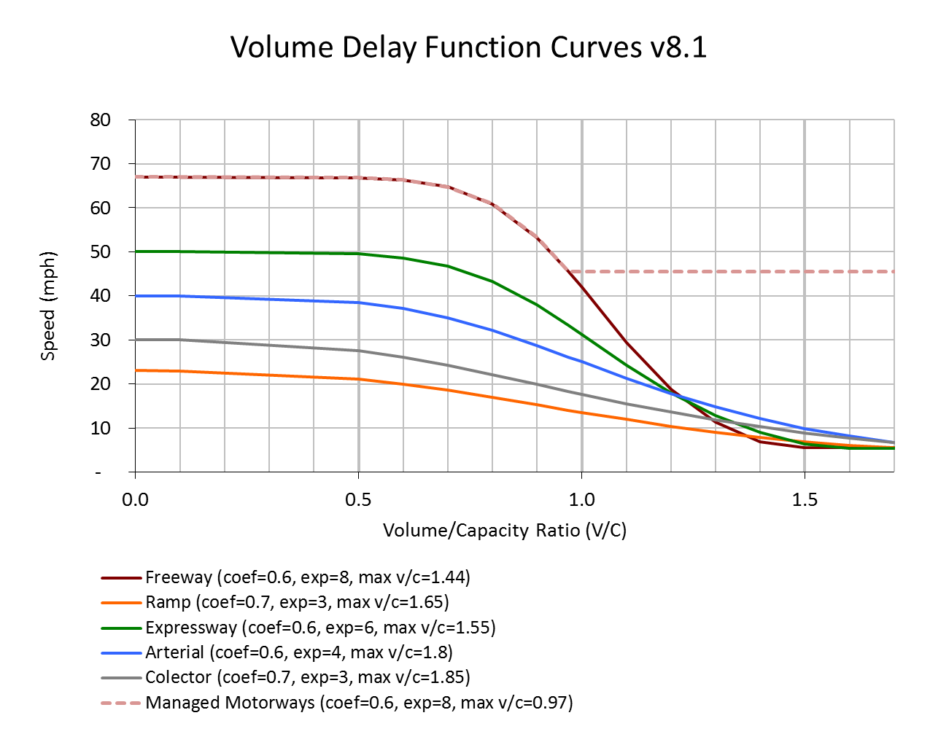

### Managed Motorways Static Input Files

The model uses two new input files to run Managed Motorways:

* ‘MM_Ramp_Penalty_Lookup.csv’ – identifies the initial ramp penalty and the subsequent adjustment factor to adjust the ramp penalty
* ‘MM_Max_Ramp_Penalty.csv’ – identifies the escalation of the maximum ramp penalty any one ramp may experience

These new input files are found in “_Inputs\6_Static\5_Assignment.” The inputs contained in each of these files are depicted in Figure 8 and Figure 9.

Figure 8: Initial Ramp Penalty and Adjustment Factor Lookup

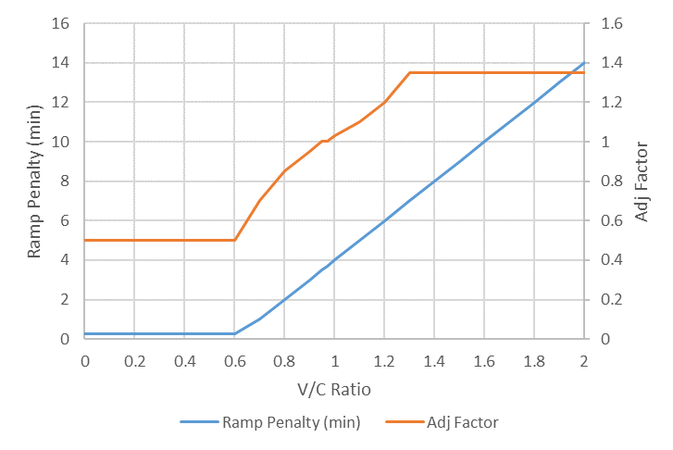

Figure 9: Maximum Ramp Penalty Lookup



The value for the ramp penalty at low V/C ratios was set to 0.25 minutes in the updated travel model. This value is reflective of the default ramp penalty assessed in the model version before this update. As an adjacent freeway link experiences more congestion (assumed in this model to begin at V/C ratio of 0.6), then the penalty on the ramp increases linearly until it reaches four minutes at a V/C ratio of 1.0. It then continues the same trajectory until it reaches a V/C ratio of 2.0. The four-minute penalty at a V/C ratio of 1.0 assumption was informed by discussions with UDOT regarding the maximum ramp penalty experienced by a user when the freeway experiences high demand. Adjustment factors in the lookup file were based on judgment and trial-and-error during model calibration.

It was observed that the maximum ramp penalty would most likely increase as the overall system experienced more congestion in the future due to pressures from increased demand. It was decided to allow the max ramp penalty to increase from four minutes in 2020 to six minutes by 2040 to reflect an increasing tolerance for congestion in the future. Beyond 2040, the maximum penalty remains capped at 6 minutes.

### Network Processor Script Edits

The travel model’s highway network processing script (“0_InputProcessing\c_NetworkProcessing\1_NetProcessor .s”) was modified to automatically identify Managed Motorways ramps and corresponding freeway links. Freeway ramps in the highway network typically are made up of multiple links in a series connecting arterials to freeways and freeways to freeways. These ramps rarely have the same number of highway links that make up the ramp or consistent lengths. It is difficult to evenly distribute ramp penalties based solely on functional type or on a rate multiplied by the ramp’s distance. The latter method—setting ramp penalties based on distance—is used by the previous version of the model to assess ramp penalties; however, this method would not work for the more complex Managed Motorways operations.

The model process was refined to automatically identify the last highway link in the ramp series that connects with the freeway. The model process assigns a unique number to both the ramp and freeway links. The freeway and ramp will have the same root identification, with the freeway link ID equal to the ramp link ID plus 1,000. Only freeway type links (functional types of 20 or more) are considered in the process. Ramp-freeway connection IDs are assigned for both general purpose and Managed Motorway links.

The model also identifies the type of ramp-freeway connection. The following IDs are used as keys later in the model processing:

* ID=1: **Ramp** link that is part of a regular ramp-to-freeway connection.
* ID=2: **Ramp** link that is part of a system-to-system ramp-to-freeway connection.
* ID=10: **Freeway** link connecting to tagged ramp link.

The model then adds two variables to the scenario network in the “Io” folder:

* RMPGID: Contains the ramp ID.
* MANFWYID: Contains the ramp-freeway connection ID.

During the link identification phase, the model also assigns the minimum ramp penalty variable from the General Parameters block file (MinRampPen) to a new variable, FF_RampPen, for all regular ramps with a nonzero RMPGID. Minimum ramp penalties are set to zero for system-to-system ramp type connections.

The model then loops through the ramps and freeway links (labeled general purpose, or GP) to determine the next 10 consecutive downstream freeway links with ramp-freeway connection IDs; it does this to identify the candidate links that may influence the ramp’s penalty. This information is then output to the “Ramp_GP_Connection.csv” file in the “Io” folder. An excerpt of this output file is shown in Figure 10.

Figure 10: Excerpt of Ramp-Freeway Lane Lookup File



### Distribution and Final Assignment Script Edits

The most significant changes to the travel model’s scripts occurred in the Distribution and Final Assignment models. The distribution script, “3_Distribute\Ds\1_Distribution.s,” is long and contains multiple processing sections. Primarily, changes occurred in the skimming, assignment (including the “Ds\block\” file), and link summary sections. Similar changes were made to the following final assignment scripts:

* In the “5_AssignHwy\As\” folder:
  + “02_Assign_AM_MD_PM_EV.s.”
  + “03_Assign_PM1Hr.s.”
  + “04_SummarizeLoadedNetworks.s.”
* In the “5_AssignHwy\As\block\” folder:
  + “4pd_mainbody_managedlanes.block.”
  + “4pd_mainbody_managedlanes_SelectLink.block.”

A summary of the changes made are included in this section of the report with additional details and notes found in the individual model scripts. Changes to the **distribution skimming** section included the following:

* Added period ramp penalty variables, *_RampPen,[1] and initialized these to the FF_RampPen.
* Conditional statements now include Managed Motorways functional types.
* Assigned Managed Motorway LINKCLASS:
  + FT=20-21 (system ramps and CD roads) to LINKCLASS 1 (freeway).
  + FT=22-27 (Managed Motorway freeway lanes) to LINKCLASS 6 (Managed Motorways).
  + FT=28-29 (Managed Motorway ramps) to LINKCLASS 2 (ramps).
* Edited generalized cost functions:
  + lw.ramppenalty replaced with li.*_RampPen * @RampPenWeight@.
  + The period specific ramp penalty equation was added to the corresponding period’s cost function.
  + RampPenWeight, found in the control center, converts ramp penalties time from actual to perceived time, which accounts for the user perception that ramp delays are more onerous than the actual time penalty would suggest (like the method used in transit path choice).
* Added total time variables that included the ramp penalty time (lw.TotTIME_* = li.*_TIME + li.*_RampPen) so time skims from the best path include the ramp delays.
* Edited PATH statements to include new variable names.

The standard use of the assignment module in Cube did not allow for iterative updating of the ramp penalties based on up or downstream congestion, which is an integral part of the Managed Motorways methodology. In consultation with Citilabs (the maker of the Cube software), a method was identified where Cube’s assignment module could be modified to account for Managed Motorways methodology. The new approach required moving the calculation of the generalized cost function working variables from the ADJUST phase, where they would typically reside, and moves them to the ILOOP phase, where they are processed in a special LINKLOOP phase. Updating the ramp penalties on each network link is only required once for each iteration of the assignment module’s convergence loop. A conditional statement was therefore put prior to the LINKLOOP phase to only run the LINKLOOP calculations for the first zone in the ILOOP phase. Finally, a set of new variables were added to the ADJUST phase to carry forward the link total volume and ramp penalty for use in the next iteration of the assignment convergence loop.

Changes to the **Distribution and Final Assignment** section (including changes to the block file) included the following:

* Read in the following additional lookup input files:
  + From “_Inputs\6_Static\5_Assignment” folder:
    - “MM_Ramp_Penalty_Lookup.csv”
    - “MM_Max_Ramp_Penalty.csv” from “_Inputs\6_Static\5_Assignment”
  + From “Io” folder
    - “Ramp_GP_Connection.csv” (note this file has a @RID_@ prefix)
* Add ramp and truck penalties—lw.RPen and lw.TPen—variables to output network.
* Changed SMOOTH from 5 to 1, based on a recommendation from Citilabs, in the assignment module’s COMBINE parameter.
* Modified the VDF lookup function to work with .csv type files instead of .dbf type files.
* Added functions to look up ramp penalties, nearest freeway ramp-freeway connection links, and the maximum penalties. (The maximum penalty lookup function uses the NEAREST command, which assigns the value in the input file nearest to the scenario year being modeled rather than using a linear interpolation between the values in the input file.)
* Modified the conditional statements and LINKCLASS variable assignment, which now follow the same pattern as the distribution script’s skimming section.
* Edited generalized cost function, which now follows the same pattern as the distribution script’s skimming section.
* Created a series of new array and link-work variables needed to perform the Managed Motorways ramp penalty calculations.
* At the start of the ILOOP phase a LINKLOOP phase is run, which performs the following calculations:
  + The model identifies a Managed Motorways ramp and looks up the 10 downstream freeway links that connect to a ramp
  + The model determines the ramp penalty at the furthest freeway location from the current ramp being evaluated. If the calculated ramp penalty is above the maximum ramp penalty threshold for that location, then the portion above the maximum threshold is transferred to the next closest ramp and added to that ramp’s ramp penalty calculation. The process repeats until the primary ramp being evaluated is reached. This process allows for the current ramp’s ramp penalty to be influenced by and to account for downstream congestion.
  + Ramp penalties are initially directly set based on the V/C ratio of the immediate adjacent freeway link. After the third iteration of the assignment convergence loop, ramp penalties are adjusted using a ramp penalty adjustment factor, which is also based on the V/C ratio. The initial ramp penalty and the ramp penalty adjustment factors are looked up from the “MM_Ramp_Penalty_Lookup.csv” input file.
  + Additional controls were added to the model to transfer of ramp penalties from one location to another to reduce the maximum ramp penalty when ramp volumes are low. Parameters for these calculations are found in the General Parameters file.
  + The model then verifies that the ramp penalty is below the maximum and above the minimum penalty allowed. It then sets the ramp penalty for the managed link to use in the path building cost function. Ramp penalties for ramps connecting to regular general-purpose lanes (i.e., non-Managed Motorway links) are not adjusted by the script and default to the minimum ramp penalty set in the General Parameters block file.
  + The model then recalculates truck times and the general costs for each link, which now includes the updated ramp penalty.
* Added congested time function for LINKCLASS 6 (TC[6]) which uses the Managed Motorways VDF parameters.
* Updated the weighting in the COST function to reflect the ramp penalty changes in the generalized cost function.
* In the ADJUST phase, print a file to the temp directory containing the ramp penalty calculations from each iteration of the assignment convergence loop for checking.
* Moved CONVERGE phase to block file from the main distribution script file.

Changes to the **Distribution and Final Assignment Link Summary** section included the following:

* Added *_RampPen to output network.
* Modified several output variable names to follow a more consistent naming convention.

In addition, a few minor changes to the distribution script’s skimming and assignment sections were made to add clarity or more convenient organization to the script or modeling process, including the following:

* Moved the following variables from the network processing script:
  + *_CAP: period capacity calculation.
  + *_VOL: period volume variable placeholder.
  + *_VC: period V/C variable placeholder.
  + *_SPD: period speed calculation.
  + *_TIME: period time variable calculation.
* Renamed free-flow speed variable, SFF, to FF_SPD to mirror the period speed variables.
* Renamed RGAPCriteria_n1_2, RGAPCriteria_n3, and RGAPCriteria_n4p variables from the General Parameters block file to better match the loops in the distribution script.
* Added PrdTag variable before each period’s assignment section; this variable is used in naming assignment output files.
* Converted assignment sections in VDF lookup file in .csv file type instead of .dbf file type for easier user editing.
* Moved Truck_Speed_Fac from the assignment block section to the General Parameters block file.
* Moved CONVERGENCE phase for assignment sections from the main distribution script to the distribution block file.

## Results

### Assignment Convergence

The Managed Motorways implementation in the travel model required a new approach to the assignment methodology, and it was unclear if the assignment convergence would be adversely affected. Figure 11, Figure 12, and Figure 13 compare the 2050 Base scenario (which included Managed Motorways on all urban interstates) to the same scenario with Managed Motorways turned off. The 2014 base year is included as a benchmark. These figures showed how the RGAP value changes with each assignment iteration. (RGAP measures the volumes change on the network between assignment iterations.) The lower the RGAP value, the more stable the volumes on the network. The travel model establishes strict RGAP convergence criteria (0.0001) as the threshold for determining assigned network stability, which aligns with standard modeling practice. Typically, more congested highway networks require more assignment iterations to reach convergence. The model also sets a limit of 100 iterations of the assignment routine to keep model runtime in a reasonable range. Assignment finishes when the model’s RGAP falls below the 0.0001 threshold or when the maximum assignment iterations is reached, whichever comes first.

Figure 11: AM Assignment Convergence Results

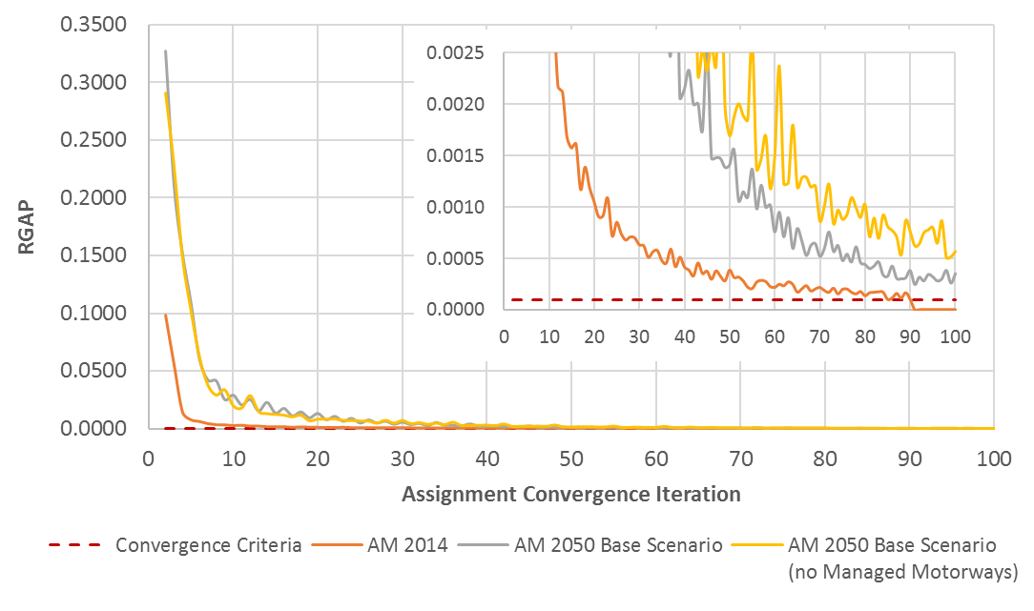

Figure 12: PM ASSIGNMENT CONVERGENCE RESULTS

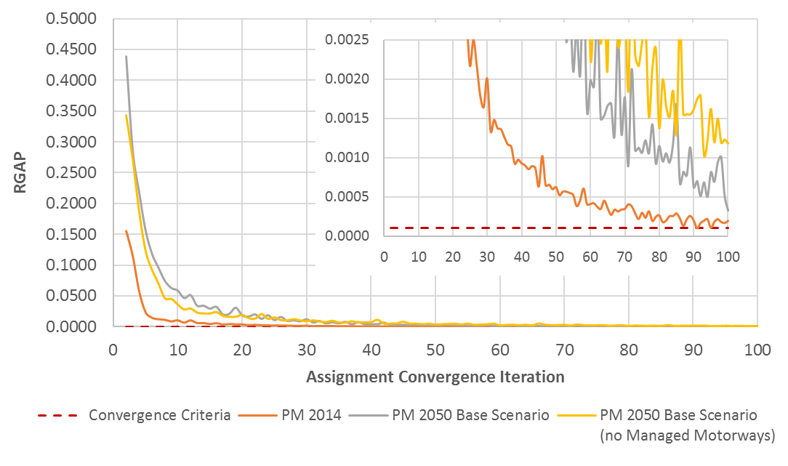

Figure 13: MD ASSIGNMENT CONVERGENCE RESULTS

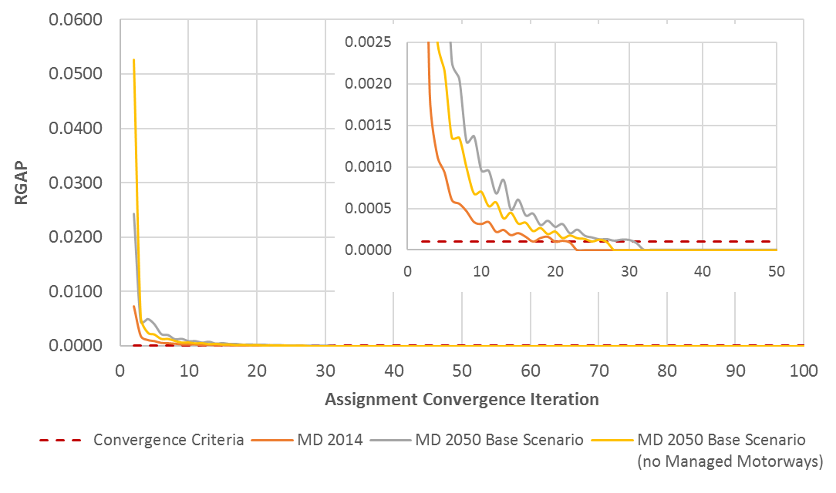

The results of the 2050 Base scenario test show that the Managed Motorways did not significantly affect the assignment model’s convergence. In more congested conditions (AM and PM peak periods), the Managed Motorways scenario showed a slight improvement in the number of assignment iterations when compared to the model run without Managed Motorways. In these scenarios, Managed Motorways also tended to dampen the oscillations in the RGAP value between iterations. In less congested conditions in the MD peak period, the Managed Motorways scenario showed the model converging in slightly more iterations.

### Ramp Penalties

The travel model dynamically sets ramp penalties in the Managed Motorways implementation based on freeway mainline congestion. Figure 14 shows the final ramp penalties for the 378 managed on-ramp locations in the 2050 Base scenario. The model set higher ramp time penalties in the more congested time periods and locations, which appears to be reasonable. (Non-Managed Motorway freeway on-ramps, such as Mountain View Corridor and West Davis Corridor, also have ramp penalties, but these ramps’ values are set to the default 0.25-minute penalty and these values do not vary based on congestion.)

Figure 14: 2050 Base Scenario Final Assignment Ramp Penalties

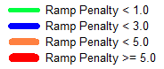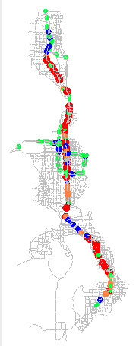 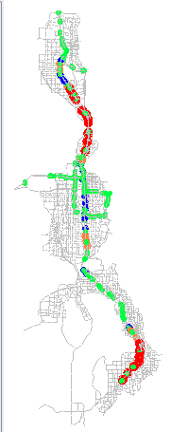 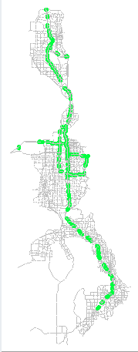

**MD**

**AM**

**PM**

### Effects on Vehicle Miles Traveled and Transit

Comparing the 2050 Base scenario with and without Managed Motorways showed that Managed Motorways had only a small effect on vehicle miles traveled (VMT) and transit ridership. In general, travelers in the Managed Motorways scenario experienced a slight benefit in travel time due to a higher level of service on the mainline even when considering the time penalty at the ramps. Better overall travel times meant travelers slightly lengthened their travel distance, resulting in a VMT increase (~3%). The results also show no significant shift in freeway versus arterial with Managed Motorways (<0.2%). Better travel times on the highways yielded slightly lower transit ridership (~1.5%). This result seems reasonable since highway and transit compete in this corridor. These results are shown in Figure 15 and Figure 16.

Figure 15: 2050 Base Scenario VMT with and without Managed Motorways



Figure 16: 2050 Base Scenario Transit Ridership with and without Managed Motorways



1. Variables in this documentation with an * in the field name represent a set of variables. The set includes the same root variable name, but the * is replaced by the period-specific prefix: AM, MD, PM, EV (sometimes FF).